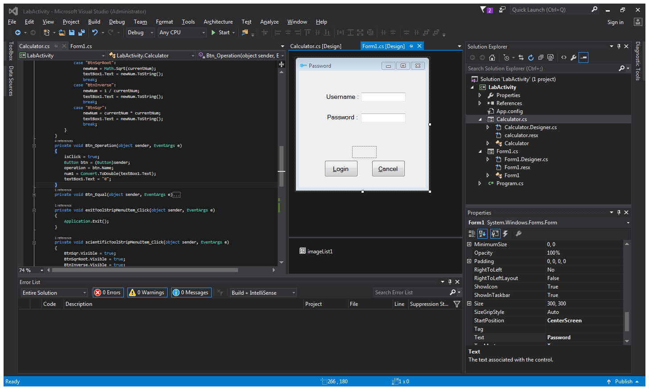Login Form

Code for login form

using System;

using System.Collections.Generic;

using System.ComponentModel;

using System.Data;

using System.Drawing;

using System.Linq;

using System.Text;

using System.Threading.Tasks;

using System.Windows.Forms;

using System.IO;

namespace LabActivity

{

public partial class Form1 : Form

{

public Form1()

{

InitializeComponent();

}

int counter = 0;

bool login = false;

string username;

string password;

private void getAccountInfo()

{

StreamReader reader = new StreamReader("info.txt");

username = reader.ReadLine();

password = reader.ReadLine();

if (textBoxUsername.Text == username &&

textBoxPassword.Text == password)

login = true;

else

login = false;

}

private void btnCancel_Click(object sender, EventArgs e)

{

textBoxUsername.Clear();

textBoxPassword.Clear();

}

private void password_textchanged(object sender, EventArgs e)

{

if (textBoxPassword.TextLength != 0)

{

btnLogin.Enabled = true;

}

else {

btnLogin.Enabled = false;

}

}

private void btnLogin_Click(object sender, EventArgs e)

{

getAccountInfo();

if (login)

{

label3.ForeColor = Color.FromArgb(50, 205, 50);

label3.Text = "Login Successful!";

pictureBox1.Image = imageList1.Images[0];

Calculator c = new Calculator();

this.Hide();

c.Show();

}

else

{

label3.ForeColor = Color.FromArgb(220, 20, 60);

label3.Text = string.Format("Username/Password is wrong! \nAttempt remains: {0}",

2 - counter);

pictureBox1.Image = imageList1.Images[1];

counter++;

if (counter == 3)

{

btnLogin.Visible = false;

btnCancel.Visible = false;

label3.ForeColor = Color.FromArgb(220, 20, 60);

label3.Text = "Your account is locked!";

}

}

}

}

}

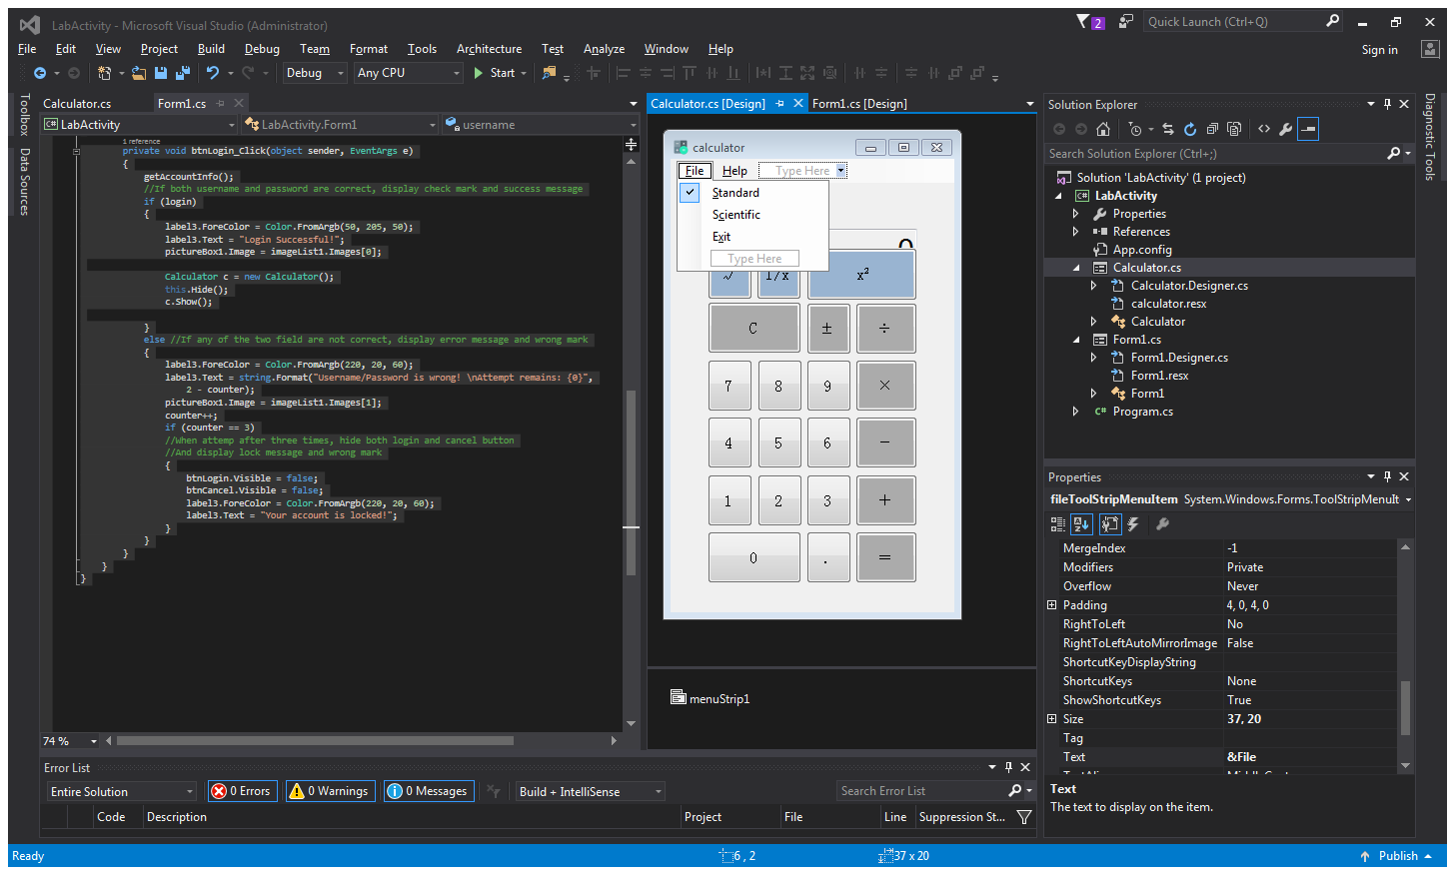Calculator Form

Code for calculator form

using System;

using System.Collections.Generic;

using System.ComponentModel;

using System.Data;

using System.Drawing;

using System.Linq;

using System.Text;

using System.Threading.Tasks;

using System.Windows.Forms;

namespace LabActivity

{

public partial class Calculator : Form

{

public Calculator()

{

InitializeComponent();

}

string operation;

double newNum = 0;

double num1 = 0;

double num2 = 0;

bool isClick = false;

private void Btn_Number(object sender, EventArgs e)

{

Button btn = (Button)sender;

if (textBox1.Text == "0")

{

textBox1.Text = btn.Text;

}

else

{

textBox1.Text += btn.Text;

}

}

private void Btn_Arithmetic(object sender, EventArgs e)

{

double currentNum = Convert.ToDouble(textBox1.Text);

Button function = (Button)sender;

switch (function.Name)

{

case "BtnDot":

if (!textBox1.Text.Contains("."))

{

textBox1.Text += ".";

}

break;

case "BtnClear":

textBox1.Text = "0";

break;

case "BtnSign":

newNum = -currentNum;

textBox1.Text = newNum.ToString();

break;

case "BtnSqrRoot":

newNum = Math.Sqrt(currentNum);

textBox1.Text = newNum.ToString();

break;

case "BtnInverse":

newNum = 1 / currentNum;

textBox1.Text = newNum.ToString();

break;

case "BtnSqr":

newNum = currentNum * currentNum;

textBox1.Text = newNum.ToString();

break;

}

}

private void Btn_Operation(object sender, EventArgs e)

{

isClick = true;

Button btn = (Button)sender;

operation = btn.Name;

num1 = Convert.ToDouble(textBox1.Text);

textBox1.Text = "0";

}

private void Btn_Equal(object sender, EventArgs e)

{

num2 = Convert.ToDouble(textBox1.Text);

switch (operation)

{

case "BtnPlus":

if (isClick)

{

newNum = num1 + num2;

num1 = num2;

isClick = false;

}

else

{

newNum = num1 + num2;

}

break;

case "BtnMinus":

if (isClick)

{

newNum = num1 - num2;

num1 = num2;

isClick = false;

}

else

{

newNum = num2 - num1;

}

break;

case "BtnMultiplite":

if (isClick)

{

newNum = num1 * num2;

num1 = num2;

isClick = false;

}

else

{

newNum = num1 * num2;

}

break;

case "BtnDivide":

if (isClick)

{

newNum = num1 / num2;

num1 = num2;

isClick = false;

}

else

{

newNum = num2 / num1;

}

break;

case "BtnResidual":

if (isClick)

{

newNum = num1 % num2;

num1 = num2;

isClick = false;

}

else

{

newNum = num2 % num1;

}

break;

}

textBox1.Text = newNum.ToString();

}

private void exitToolStripMenuItem_Click(object sender, EventArgs e)

{

Application.Exit();

}

private void scientificToolStripMenuItem_Click(object sender, EventArgs e)

{

BtnSqr.Visible = true;

BtnSqrRoot.Visible = true;

BtnInverse.Visible = true;

textBox1.Location = new Point(37,37);

standardToolStripMenuItem.Checked = false;

scientificToolStripMenuItem.Checked = true;

}

private void standardToolStripMenuItem_Click(object sender, EventArgs e)

{

BtnSqr.Visible = false;

BtnSqrRoot.Visible = false;

BtnInverse.Visible = false;

textBox1.Location = new Point(37, 70);

standardToolStripMenuItem.Checked = true;

scientificToolStripMenuItem.Checked = false;

}

private void aboutToolStripMenuItem_Click(object sender, EventArgs e)

{

MessageBox.Show("This is written by Kim Yang!", "About", MessageBoxButtons.OK);

}

}

}